Life After De Minimis: How EU E-Commerce Imports Will Change from 2026.
cormac658
Jan 13
3 min read
Updated: Jan 21

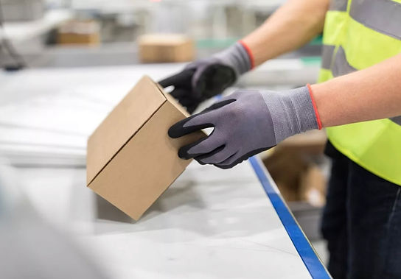
The continued expansion of e-commerce has been one of the most significant drivers of change in international trade in recent years. Online platforms have enabled consumers to purchase goods from sellers anywhere in the world with just a few clicks, while advances in logistics and fulfilment have made rapid cross-border delivery the norm rather than the exception. This growth has been particularly pronounced in low-value consumer goods, where overseas sellers can reach EU customers directly, often at prices that domestic businesses struggle to match. A key factor in enabling this model has been the EU’s de minimis rule, which exempted imports valued under €150 from customs duties. While originally designed to reduce administrative burden for customs authorities, the rule increasingly became a commercial advantage for non-EU traders.

By removing customs duties on low-value consignments, the de minimis threshold allowed foreign sellers to avoid costs that EU-based businesses could not. This created an uneven playing field, particularly in sectors dominated by fast-moving consumer goods and online marketplaces. Over time, the volume of parcels entering the EU under this exemption grew exponentially, placing strain on customs controls and contributing to lost revenue for member states. Concerns also emerged around compliance, product safety, and fair taxation. These pressures have led the EU to reassess whether the exemption remains fit for purpose in a trade environment dominated by high-volume e-commerce rather than occasional low-value imports.

The EU has now confirmed that the €150 customs duty exemption will be removed, with the change expected to take effect from 2026. This represents a significant shift in how low-value e-commerce imports will be treated. Once implemented, all commercial goods entering the EU will be subject to customs duties, regardless of value. For international sellers and online marketplaces, this will require a reassessment of pricing strategies, shipping models, and customer expectations. For the customs and logistics industries, the impact will be substantial. Declaration volumes are expected to rise sharply, particularly for small parcels, and there will be increased demand for automated, compliant clearance solutions that can operate at scale without causing delays at the border.

To address this challenge, the EU is placing strong emphasis on simplified customs procedures for low-value consignments. The H7 customs declaration is central to this approach, allowing for streamlined processing with reduced data requirements compared to full import declarations. This simplification is intended to support trade flow while maintaining effective customs control and revenue collection. However, simplified does not mean optional. Accurate data submission, correct classification, and proper valuation will remain essential. In parallel, handling fees and customs processing charges are expected to become a routine cost for e-commerce operators, reflecting the additional work required to process a vastly increased number of declarations.

For logistics providers and customs intermediaries, this shift presents both challenges and opportunities. The ability to handle large volumes of H7 declarations efficiently, while maintaining compliance across multiple jurisdictions, will become a key differentiator. Businesses that are unprepared for the operational and regulatory demands of the new system risk delays and, increased costs.

As the end of the de minimis era approaches, Customs Wise is already supporting our clients in preparing for this transition. With a dedicated H7 customs team and a wealth of experience in high-volume e-commerce movements, Customs Wise is well positioned to help your business adapt to the new rules. By combining regulatory expertise with practical solutions, we can ensure that your business can continue to trade smoothly while remaining fully compliant with evolving EU customs requirements. In a rapidly changing trade environment, preparation is essential, and here at Customs we’re committed to guiding our clients through every stage of this industry-wide change.

